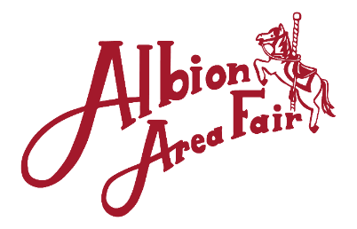
2024 Premium Book Ad & Sponsorship Form
Company Name:_________________ Contact Person:______________________
Street Address / State / ZIP:_________________________________________________
Phone:__________________ eMail:___________________________________
VIP Parking Space ($100 each) [ ___ ]
VIP package includes two Booster Buttons for weeklong fair entry. VIP parking spaces are limited. Please reserve now. Send payment to address below.
Parking Areas include: Near the Log Cabin or by the Lower Fair Office.
DIGITAL IMAGE REQUIREMENTS for Ads: MINIMUM 300 dpi in a common format such as JPEG, PNG, PDF. VECTOR artwork required for a banner or $75 set up fee will apply. All artwork email to: albionfairbook@gmail.com

Thank you for your
continued support of
The Biggest Little Fair Around.
Fair Book Ad
NEW [__] or REPEAT [__]
1/8 Page: [_] B/W $75 [_] Color $100
1/4 Page: [_] B/W $125 [_] Color $175
1/2 Page: [_] B/W $200 [_] Color $275
Full Page: [_] B/W $325 [_] Color $400
Based on an 8”x10.5” Page.

4’ x 6’ Vinyl Banner
Color
$250 (new) [__ ] / $150 (renewal) [__]
Please mark preferred location:
[__] Main Entrance [__] Pulling Track
[__] Knapp Arena
[__] Practice Arena
Event Sponsor (requires a minimum $500 contribution that includes a 4’ x 6’ Banner, web site ad and business name announced at specified event):

Horse Show [$_____] A Tractor Pull [$_____] Queen/Junior Miss Pageant [$_____]
Truck Pull [$_____] Parade [$_____] Concert/Music [$_____]
Barn: [$_____] Shuttle Carts [$_____] Your Choice: _________________

Total Amount Enclosed: _____________________
PLEASE RETURN THIS FORM WITH PAYMENT BY May 1st.

